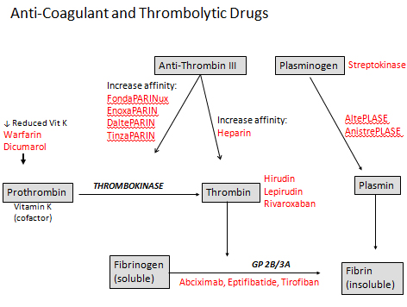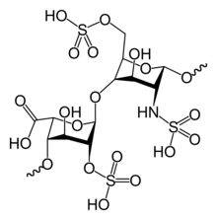Treatment of Thromboembolism – Thrombolytic - Direct



Thrombolytic

1. General: Break and clear existing clots
2. Treat: DVT Deep Vein Thrombosis
3. Drugs:
   1. Non-specific
      1. Streptokinase
      2. Urokinase
   2. Specific
      1. Tpa (Alteplase)
      2. Rpa (Reteplase)
      3. TnKase (Tenecteplase)

Treatment of DVT/PE

1. DVT = Deep Vein Thrombophlebitis thrombosis deep inside body
   1. Post-Phlebitic Syndrome: Chronic version
2. PE = Pulmonary Embolism main artery of lung (heart to lung)
3. Test = positive to thromboembolism
   1. Anticoagulant
      1. If contraindicated to heparin inferior vena caval filter
   2. If PE…
      1. Thrombolytic therapy
      2. If contraindicated to thrombolytic IV Warfarin + Heparin

***Methods of DVT Prophylaxis***

|  |  |
| --- | --- |
| **Method** | **Description** |
| **Low Dose UFH** | 5,000 U heparin SQ q8-12hrs (DO NOT CHECK PTT) |
| **LMWH** | Dalteparin 2500 IU SQ Daily (medical pts)  5000 IU SQ daily (surgical pts)  Don’t use if CrCl < 30 ml/min  Enoxaparin: 30 mg SQ Q12 hrs (Orthopedic and high risk surgery)  30 mg SQ Daily (CrCl 10-30 ml/min)  40 mg SQ Daily (Medical patients) |
| **Pentasaccharides**  **(5/2 = 2.5)** | Fondaparinux 2.5 mg SQ Daily  Don’t use if CrCl < 30 ml/min or weight < 50kg |
| **Adjusted-dose perioperative warfarin** | Start daily dose (5 mg) the day of or the day after operation;  adjust dose for INR 2-3 |
| **Minidose warfarin** | Start 1 mg/d aiming for INR = 1.5 after operation (evidence is poor) |
| **Intermittent Pneumatic Compression (IPC)/Graded Compression Stockings (GCS)** | Start immediately before operation, and continue until fully  ambulatory, usually adjunctive therapy with pharmacologic therapy  who are high risk of bleeding |